**Brain Computer Interface**

*Daniel Elstob*

*Liverpool Hope University*

[*14011862@hope.ac.uk*](mailto:14011862@hope.ac.uk)

**Introduction and Motivation**

With the advancements of technology and the increase of ubiquitous computing devices there is a developing need for an approach that will allow communication with devices that isn’t limited to the current physical interaction. There is a particularly strong desire from the medical field to produce an alternate form of communication for those who are unable to with the outside world. From these aims research has produce a variety of ways to make a brain communicate directly with an external device such as Brain-Computer Interface (BCI) or Brain-Machine Interface (BMI). This paper will look at the research and applications being undertaken on Brain Computer Interfaces as well as the emerging research of Brain-to-Brain Interfaces (BTBI).

**Theoretical and Technical and Foundations**

**Introduction**

Mak and Wolpaw define BCI as “a communication and/or control system that allows real-time interaction between the human brain and external devices” (Mak and Wolpaw, 2009). Vidal, who is considered as the inventor of BCI, started researching this field in the 1970 at the University of California (Vidal, 1973). This field focused on the aim of BCI that could assist, augment or repair human cognitive or sensory-motor functions. Due to this, the research and development of BCI are focused on neuroprothetics, prosthetics that aim towards the improvement or rehabilitation of people with amputations or similar disabilities. This is made possible through neuroplasticity also known as brain plasticity which according to Pascual-Leone et al. “can be conceptualised as nature’s invention to overcome limitations of the genome and adapt rapidly changing environment” (Pascual-Leone et al., 2011). As a result the signals received from implanted prosthetics, after training, can be handled by the brain like natural sensor or effector channels of a limb.

Wolpaw discusses that there are essentially four key elements of BCI, signal production, signal detection, signal processing signal output (Wolpaw et al., 2002).

**Signal Production**

Brain signals need to be produced by the subject in order to be used. These signals could be the brain waves that are already generated subconsciously, which can be harder to detect, or actively generated through stimuli which the subject would have control over and could increase the strength through concentration.

**Signal Detection**

There are various ways to detect the necessary signals. The most popular approaches are ElectroEncephaloGraph (EEG) used to detect brain signals, ElectroMyoGraph (EMG) which is for muscles and Functional Magnetic Resonance Imaging (fMRI) measures the blood flow in the brain. Some other less popular approaches are MagnetoEncephaloGraphy (MEG) and ElectroCorticoGraphy (ECoG). Depending on the purpose of detecting the signals each approach will have its strengths and weaknesses such as better temporal resolution or spatial resolution.

**Signal Processing**

One of the major problems of from signal detecting is that a lot of noise is produced. For example when using EEG things like eye movement and facial reactions will be included in the data. This is where signal processing is used to filter the excess noise out of the data you have collected so that the data can be used for detecting actual brain signals.

**Signal Transduction**

Once you have detected the desired signals in your data, you can use them. For example the subject could use the BCI to control the movement of a robot by assigning the movement of a limb to a direction the robot can move in. However an issue you will encounter here is that you need to use the data as efficiently as possible, whilst understanding that that BCI's can make mistakes. Current BCI's can be slow and make mistakes about distinguishing different brain signals.

**Basics & Foundation to BCI**

BCIs can be categorized into three types, invasive, non-invasive and partially invasive depending on the placement of the sensors that are used to detect brain waves

Invasive BCIs are surgically implanted directly into the brain. This gives them the best signal quality however as a foreign object the body will react to it causing scar tissue build up which will weaken the signal or cause it to become non-existent. These types of BCI are used to assist or treat individuals with more severe disabilities such as full body paralysis (Birbaumer, Murguialday and Cohen, 2008) or acquired blindness (Dobelle, 2000).

Non-invasive BCIs are a non-surgical approach of reading signals from outside the head the signals are much weaker as they have to pass through the skull as well as pick up excess noise from facial movements. This approach would use EEG to control external devices or prosthetics (Pfurtscheller et al., 2003).

Partially invasive BCIs are, like invasive, surgically implanted inside the skull but unlike invasive they are outside of the brain. This gives them a midpoint between invasive and non-invasive. They produce better signal that non-invasive BCIs as the signals do not have to pass through the skull before being received and because they are not implanted into tissue making them less likely to form scar tissue. Yanagisawa showed that this approach could be useful to those with motor disabilities like lock-in syndrome using ECoG (Yanagisawa et al., 2011).

**Literature review**

Research in this field was first started by Vidal with his work on “direct brain-computer communication” (Vidal, 1973) and later his work on “Real-time detection of brain events in EEG” (Vidal, 1977). This caused a lot of interest particularly with DARPA. With interest from the military and with BCI showing promising results for medical applications, research began on different forms of augmentation with focus on prosthetics.

There was not much progress in research until the 1990’s at which point there was a boost in the advances of the research. The first of this pioneering research was done by Wolpaw et al. with an alternate approach to a BCI system using electroencephalograms (Wolpaw et al., 1990). A year later a communication approach by Wolpaw et al. were they designed a system with a cursor on the screen which the subject would control with thought (Wolpaw et al., 1991).

In the late 90’s another communication system was designed by Farwell and Donchin was to use “the P300 component of the event-related brain potential (ERP)” (Farwell and Donchin, 1998) to aid those with motor related disabilities. This experiment involves a screen with 26 letters and the subject had to concentrate on the letter they wanted at which point the computer detects in real-time the chosen character.

Levine et al. explored “a direct brain interface based on event-relate potential” (Levine et al, 2000) and showed that this different system was able to produce the same level of accuracy that the other systems at that time could.

Some researchers had instead of focusing on communication based systems looked at prosthetics that would aid people’s daily lives. One approach to a BCI prosthetic by Muller-Putz and Pfurtscheller used a steady state visually envoked potential (SSVEP) system “to control a two-axis electrical hand prosthesis” (Muller-Putz and Pfurtscheller, 2008). This experiment involved four human subjects to control and perform certain movements. It showed that this type of BCI system was feasible for the controlling of a neuroprosthetic.

**Emerging Technologies, Innovations and Applications**

**Advances in research**

Nijholt explores the “possibilities of brain-computer interface application that assume two or more users” (Nijholt, 2015) an idea first introduced in the early seventies but due to a lack of technology support for advanced signal processes faded only to have recently resurfaced. However recent research has focused on the possibility of using BCI to connect different brains together directly, with the aim to have collaborative decision making.

Researchers at Duke University in Durham, North Carolina, USA, and Natal, Brazil reported they connected the brains of two rats to cooperate in simple tasks in order to obtain a reward. One task involved separating the rats into different compartments, one rat had a light and a level and the other had just a lever. When the light was turned on the rat was to pull the lever and if both successfully pulled their lever they were rewarded. This task resulted in a 70% success rate. Another of these experiments involved connecting the rats via the internet and having the rats in different countries, USA and Brazil, where they were able to cooperate to perform simple tasks together to obtain a reward. “These results demonstrated that a complex system was formed by coupling the animals' brains, suggesting that BTBIs can enable dyads or networks of animal's brains to exchange, process, and store information and, hence, serve as the basis for studies of novel types of social interaction and for biological computing devices” (Pais-Vieira et al., 2013).

Researchers then began applying a similar method to humans using non-invasive technologies. Roa et al. performed “experiments involving six different subjects” (Roa et al., 2014). Similar to the experiment performed by the rats, “two participants had to carry out a specific task in the form of a series of consecutive trials of a computer game” (Roa et al., 2014) and the game required cooperation as one of the subjects was the sender able to see the game but had no input to control it and the second as the receiver had an input device to interact with the game but could not see the screen as illustrated in Figure 1.

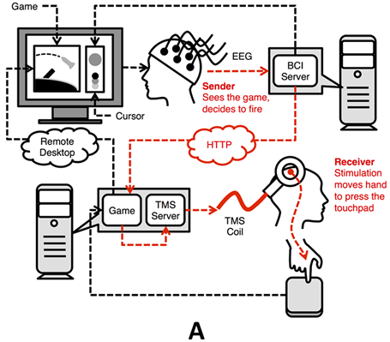

Figure 1 Brain to Brain Interface

Expanding on the collaborative thought research other researchers aimed to “demonstrate the feasibility of direct brain-to-brain communication” (Grau et al., 2014). This research involved having four human subjects with one assigned to be an emitter who would give orders and the other three would be recipients who receive messages. The aim was to see if communication could go beyond verbal and it was shown that “streams of pseudo-random bits representing the words “hola” and “ciao” were successfully transmitted mind-to-mind between human subjects separated by a great distance, with a negligible probability of this happening by chance”(Grau et al., 2014). This potentially offers a new form of communication to those that have motor or sensory disabilities and cannot communicate with other in the world.

In 2014 researchers used near-infrared spectroscopy (NIRS), for “locked-in” patients with amyotrophic lateral sclerosis (ALS) and were able to restore some basic ability of the patient’s communication (Gallegos-Ayala et al., 2014) displaying a new approach towards treating paralysis with BCI.

**Application of Research**

BCI consumer sold applications are usually headsets that have dry sensors, brain wave noise reduction and are wire-free often using bluetooth to connect with mobiles or computers. This makes them much more desirable that the gel based caps that research will often use.

NeuroSky inc. is and American company that sells consumer BCI. They began with research in 1999 and were incorporated in 2004 by Stanely Yang. The company quickly caught the interest with their breakthrough in harnessing the brain waves found in EEG machines that would $20,000 and into headsets that consumers could afford. In 2011 NeuroSky revealed the MindWave costing $99.95 as presented in Figure 1. This was a headset to cater directly at the consumer market offering a single dry sensor that located on the user’s forehead however this positioning can cause issues with the acquisition of signals as it cannot distinguish between facial muscles movement and brain activity. With the upcoming release of Google Glass NeuroSky partnered with This Place in 2014 to create MindRDR an application that connects the MindWave sensor to Google Glass that would allow it to share photos on social media without physical or verbal interaction.

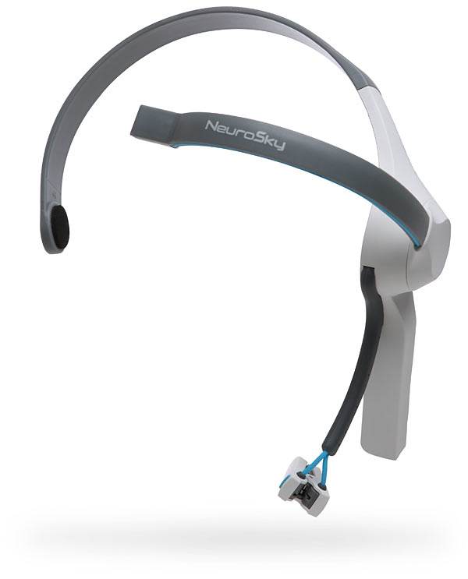

Figure 2 NeuroSky MindWave

Emotiv Systems, an Australian company, also develops consumer BCI products using EEG technology. Their first product was the Emotiv EPOC, a peripheral device costing between $399 and $499 that offered SDK/developer tools as presented in Figure 2.With 14 saline-based sensors located all over the head the EPOC, compared to other consumer products, is the preferred choice for researches as they can detect the brain activity in the frontal lobe and are able to classify and dismiss the muscles’ signals based on the different sensors as well as get good quality data even through hair.

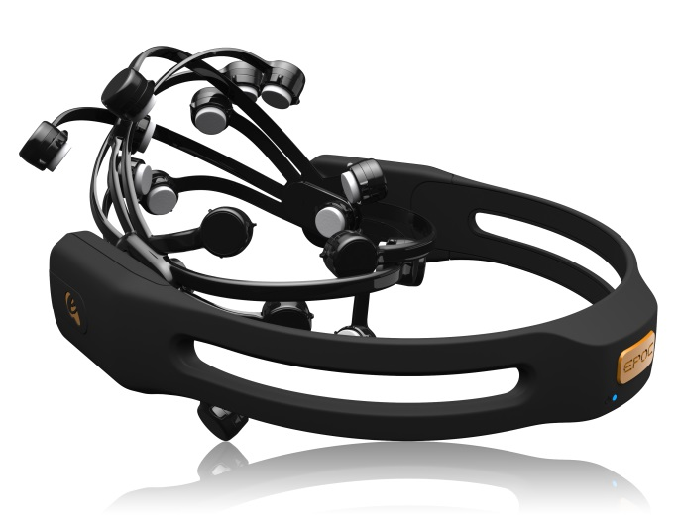

Figure 3 Emotiv EPOC

Emotiv systems have also produced a new headset developed and funded with the community using Kickstarter called Emotiv Insight presented in Figure 3. This is “a sleek, multi-channel, wireless headset that monitors you brain activity and translates EEG into meaningful data you can understand.” (Emotiv, 2014). It will cost $299 and have multi-platform SKD access.

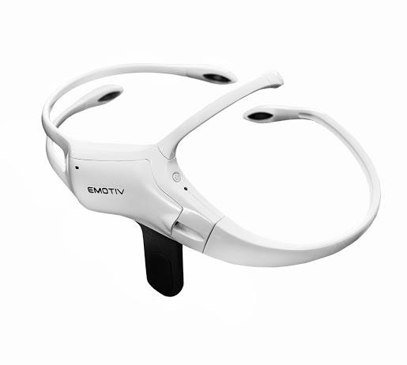

Figure 4 Emotiv Insight

Unlike the EPOC which is more suited for research in a controlled environment the Insight claims that it is designed for everyday use and can produce clean, robust signals anytime, anywhere. The “Emotiv Insight is the only device on the market that offers 5 EEG + 2 reference sensors, achieving high spatial resolution providing more in-depth information on your brain.” (Emotiv, 2014). As well as these sensors the headset has 9-axis inertial sensors that provide additional feature such as gyroscope for orientation, accelerometer for speed in a certain direction and magnetometer for an absolute change in orientation and position. With these features developers and researchers will be able to use these new inputs to detect head movements or gestures such as nodding or shaking the head side to side.

Unlike the Neurosky headsets which have a dry sensor the Emotiv Insight uses a hydrophilic polymer sensor that can detect brain signals, similar to the saline-based senor of the EPOC, with the convenience of a dry sensor. This means there is no need for extensive preparation or conduction materials like gels or saline solutions as it absorbs moister from the environment.

Prosthetic limbs are one of the oldest medical technologies that exist and BCI’s show promise to evolve current prosthetics offering users the ability to get back some functionality and improve their daily life. Currently BCI prosthetics make use of electrodes that are stuck to the surface of the skin. However this has major limitations because of inference from electrical activity elsewhere in the body, known as “cross-talk” or any electromagnetic interference from electrical devices or power lines. There can also be affects from environmental conditions such as temperature that change the skin state or by limb motions that displace the skin over the muscles. In addition, the current socket prosthetics design, which has constant pressure placed on it from the user, can cause pain and tissue damage. These problems lead to many amputees giving up on their prostheses.

With the aim to improve upon these drawbacks researchers from Chalmers University of Technology “developed a percutaneous osseointegrated (bone-anchored) interface that allows for permanent and unlimited bidirectional communication with the human body” (Ortiz-Catalan, Håkansson and Brånemark, 2014). The test subject that received this augmentation in January 2013 had the prosthetic attached directly to his humerous which provided a mechanically stable connection as illustrated in figure 5. As a consequence of this there is an increased sensory feedback due to the direct transmission of forces and vibrations to the bone (Häggström et al., 2013). His nerves and muscles are directly connected to the machine’s control systems via neuromuscular electrodes which are shield from the environmental and electromagnetic conditions by his body. This integration provides the user with greater control and precision over the prostheses with less effort due to the increase motor neurons. After the first fitting of the controller, little or no recalibration is needed because there is no need to reposition the electrodes on every occasion the prosthetic is work as opposed to superficial electrode or socket prosthetics.

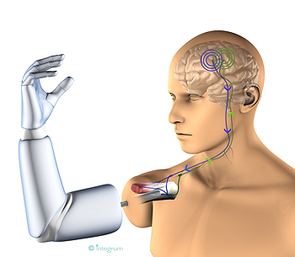

Figure 5 Implanted Prosthetic

“This creates an intimate union between the body and the machine; between biology and mechatronics” (Ortiz-Catalan, Håkansson and Brånemark, 2014). The subject is the first to use this new style of limb prosthetic and achieve long-term sensation via prosthesis. Due to its design as shown in figure 6 the joint is incorporated into the prosthetic allowing for an increased range of motion with a stable and easy attachment or detachment. As a result of this pain and tissue damage is eliminated as there is no constant pressure on it and it can be worn all day, every day. Furthermore because it is a bidirectional interface it can also be used to send signals in the opposite direction, from prosthetic to the brain, which provides the next step for researchers to develop a prosthesis which allows the patient to feel sensations.

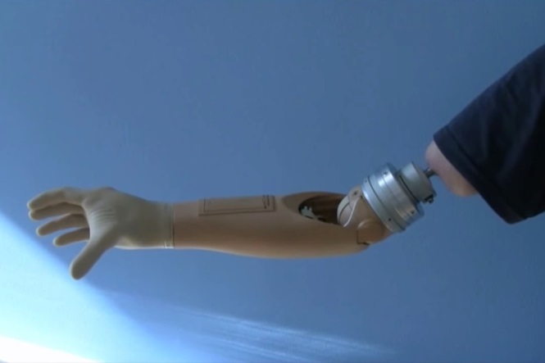

Figure 6 Osseointergrated Prosthetic

**Critical Reflection and Conclusions**

This paper has investigated BCI systems, discussing the essential requirements of the system and the goals that have driven BCI research over the past decades have been presented. BCI research has been able to achieve a lot in two decades compared to other technologies as many of the methods used are based on previous signal processing research.

Different approaches have been successfully applied in BCI such as the most popular, EEG, which provides acceptable quality signals with high portability and the chosen approach for commercial products. ECoG was also discussed and showed promise in the medical field for patients with motor disabilities. Using EEG methods allows for uses to spend less time training the BCI and will cause an abundance of BCI applications in the daily life of disabled people to allow them to perform tasks such as access the internet for email or social media, be able to control wheelchairs or even control prosthetics. Additionally, with the increase of commercial interest within certain companies suggests that BCI systems may find useful applications in the general population, and not solely for people living with disabilities. The applications that are being offered from companies such as NeuroSky and Emotiv are designed around mental and physical health for example meditation or an aid to cardio exercises. With this type of goal BCI systems in the near future may therefore become a new mode of human-machine interaction with levels of everyday use that are similar to other current interfaces.

Within the field of neuroprosthetics the current advancement of the prosthetic through osseointergration (bone-anchored) and having the electrodes on the nerves and muscles provides many benefits compared to the socket prosthetics that are used by the general public. With this new technology there is an increased range of motion and because it is anchored directly into the bone it is much more stable granting all day use without causing any sores or pain in the user. Due to the close proximity between the electrode and the source it prevents any inferring allowing the user to remain in full control to perform more delicate tasks for example tying a shoe lace whilst not being affected by outside conditions that other prosthetics might. Furthermore having electrodes directly connected to the nerves means that they can handle bidirectional signals, able to send signals to the brain as well as receive them opening up new hope to the users for being able to perceive sensations. However even with these benefits there are still potential hindrances to whether this method will become a suitable treatment option for everyone. Medical researchers have performed studies to see the long term affects in patients and have reported that “walking aids used and the presence of phantom limb pain and pain in other extremities were unchanged” for “percutaneous osseointergrated prostheses” (Hagberg, Hansson and Brånemark, 2014).

In spite of these important advances there are still issues that need to be solved within the BCI field. Moore explains that there are four main challenges in using BCI in real-world tasks are “information transfer rate”, “high error rate”, “autonomy” and “cognitive load” (Moore, 2003).

Information transfer rate relates to the information transferring between the user and the device when attempting to perform a task. On average the BCI systems are “too slow for natural interactive conversation” (Moore, 2003) and it is due to amount of signals that can be sent from brain to device. Yuan et al. goes into great detail about all the different factors that can contribute to the speed and the ways to improve this process (Yuan et al., 2013).

High error rate is a significant factor in information transferal because “brain signals are highly variable, and this problem is exacerbated in severely disabled users by fatigue, medications, and medical conditions such as seizers or spasms” (Moore, 2003). Researchers at IDIAP have been investigating ways “to improve the robustness, flexibility and reliability of BCIs” (Buttfield, Ferrez and Del R. Millan, 2006) to help with this issue.

Autonomy concerns how the BCI will be used and in this case it refers to disabled people. BCI systems require assistants to apply the sensors whether that be sensor or a headset. There is also the issue of turning the system on and off, “a BCI user may be able to perform a selection to turn the BCI system off, but turning it on again is an issue” (Moore, 2003).

Cognitive load is one of the biggest issues in BCI systems. When researchers are developing a system they can control a lot of the factors when testing, however in the real world there will be a lot more factor and complex situations that can affect whether it can even be used. Sellers et al. discuss about how their “2.5 year study investigated independent home use of a newly developed non-invasive EEG-based BCI system by a person with ALS” (Sellers, Vaughan and Wolpaw, 2010), which showed promising results towards handling cognitive load.

In conclusion the field of BCI has, with the advances in technology, broadened in its applications and by combining it with other fields such as human-computer interface (HCI) and neuroscience it has been able to bring in new approaches to tackle the current problems and pursue new areas such as sharing information through thought and collaborative decision making as well as improvement in neuroprosthetics that allow the user to augment a part of their body with technology that can act almost to a level of the biological counterpart. The original aim of BCI system were to assist, augment or repair human cognitive or sensory-motor functions however with the abundance of ubiquitous computing and more development into augmented technologies such as the google glass the aim of research could shift to the assisting or augmented the general populace’s health rather than just those with disabilities.

**References**

Birbaumer, N., Murguialday, A. and Cohen, L. (2008). *Brain–computer interface in paralysis*. Current Opinion in Neurology, 21 (6). pp. 634-638.

Buttfield, A., Ferrez, P. and Del R. Millan, J. (2006). *Towards a Robust BCI: Error Potentials and Online Learning*. IEEE Transactions on Neural Systems and Rehabilitation Engineering, 14 (2). pp. 164-168.

Dobelle, W. (2000). *Artificial Vision for the Blind by Connecting a Television Camera to the Visual Cortex*. ASAIO Journal, 46 (1). pp. 3-9.

Emotiv (2014) Retrieved from https://emotiv.com/insight.php

Farwell, L.A. and Donchin, E. (1988). *Taking off the top of your head: toward a mental prostheses utilizing event-related brain potentials*. doi:10.1016/0013-4694(88)90149-6

Gallegos-Ayala, G., Furdea, A., Takano, K., Ruf, C., Flor, H. and Birbaumer, N. (2014). *Brain communication in a completely locked-in patient using bedside near-infrared spectroscopy*. Neurology, 82 (21). pp. 1930-1932.

Grau, C., Ginhoux, R., Riera, A., Nguyen, T., Chauvat, H., Berg, M., Amengual, J., Pascual-Leone, A. and Ruffini, G. (2014). *Conscious Brain-to-Brain Communication in Humans Using Non-Invasive Technologies*. PLoS ONE, 9 (8). p.e105225.

Hagberg, K., Hansson, E. and Brånemark, R. (2014). *Outcome of Percutaneous Osseointegrated Prostheses for Patients With Unilateral Transfemoral Amputation at Two-Year Follow-Up*. Archives of Physical Medicine and Rehabilitation, 95 (11). pp. 2120-2127.

Häggström, E., Hagberg, K., Rydevik, B. and Brånemark, R. (2013). *Vibrotactile evaluation: Osseointegrated versus socket-suspended transfemoral prostheses*. J Rehabil Res Dev, 50 (10). pp. 1423-1434.

Levine, SP; Huggins, JE; Bement, SL; Kushwaha, RK; Schuh, LA; Rohde, MM; Passaro, EA; Ross, DA; Elisevich, KV et al. (2000). *A direct brain interface based on event-related potentials*. IEEE transactions on rehabilitation engineering : a publication of the IEEE Engineering in Medicine and Biology Society. 8 (2). pp. 180–185. doi:10.1109/86.847809. PMID 10896180

Mak, J. and Wolpaw, J. (2009). *Clinical Applications of Brain-Computer Interfaces: Current State and Future Prospects*. IEEE Reviews in Biomedical Engineering, 2. pp. 187-199.

Moore, M. (2003). *Real-world applications for brain~computer interface technology*. IEEE Transactions on Neural Systems and Rehabilitation Engineering, 11 (2). pp. 162-165.

Muller-Putz, G. R., and Pfurtscheller, G. (2008). *Control of an electrical prosthesis with an SSVEP-based BCI*. Biomedical Engineering, IEEE Transactions on,  55 (1). pp. 361-364.

Nijholt, A. (2015). *Competing and collaborating brains: multi-brain computer interfacing*. Springer International Publishing. pp. 313-335.

Ortiz-Catalan, M., B. Håkansson, and Brånemark, R. (2014). *An Osseointegrated Human-Machine Gateway For Long-Term Sensory Feedback And Motor Control Of Artificial Limbs*. Science Translational Medicine 6 (257)

Pais-Vieira, M., Lebedev, M., Kunicki, C., Wang, J. and Nicolelis, M. (2013). *A Brain-to-Brain Interface for Real-Time Sharing of Sensorimotor Information*. Scientific Reports, 3.

Pascual-Leone, A., Freitas, C., Oberman, L., Horvath, J., Halko, M., Eldaief, M., Bashir, S., Vernet, M., Shafi, M., Westover, B., Vahabzadeh-Hagh, A. and Rotenberg, A. (2011). *Characterizing Brain Cortical Plasticity and Network Dynamics Across the Age-Span in Health and Disease with TMS-EEG and TMS-fMRI. Brain Topogr*. 24 (3-4), pp. 302-315.

Pfurtscheller, G., Müller, G., Pfurtscheller, J., Gerner, H. and Rupp, R. (2003). *‘Thought’ – control of functional electrical stimulation to restore hand grasp in a patient with tetraplegia*. Neuroscience Letters, 351 (1). pp. 33-36.

Rao, R., Stocco, A., Bryan, M., Sarma, D., Youngquist, T., Wu, J. and Prat, C. (2014). *A Direct Brain-to-Brain Interface in Humans*. PLoS ONE, 9 (11). p.e111332.

Sellers, E., Vaughan, T. and Wolpaw, J. (2010). *A brain-computer interface for long-term independent home use*. Amyotroph Lateral Scler, 11 (5). pp. 449-455.

Vidal, JJ. (1973). *Toward Direct Brain-Computer Communication*. Annual Review of Biophysics and Bioengineering, 2 (1). pp. 157-180.

Vidal, JJ. (1977). *Real-time detection of brain computer events in EEG*. In: Proceeding of the IEEE 65 (5). pp. 633-641.

Wolpaw, J., Birbaumer, N., McFarland, D., Pfurtscheller, G. and Vaughan, T. (2002). *Brain–computer interfaces for communication and control*. Clinical Neurophysiology, 113 (6). pp. 767-791.

Wolpaw, J., McFarland, D., Neat, G. (1990). *Development of an Electroencephalogram-based Brain-Computer Interface.* Annals of Neurology, 2 (2). pp. 250-251.

Wolpaw, J., McFarland, D., Neat, G. and Forneris, C. (1991) *An EEG-based brain-computer interface for cursor control*. doi:10.1016/0013-4694(91)90040-B

Yanagisawa, T., Hirata, M., Saitoh, Y., Kishima, H., Matsushita, K., Goto, T., Fukuma, R., Yokoi, H., Kamitani, Y. and Yoshimine, T. (2011). *Electrocorticographic control of a prosthetic arm in paralyzed patients*. Annals of Neurology, 71 (3). pp. 353-361.

Yuan, P., Gao, X., Allison, B., Wang, Y., Bin, G. and Gao, S. (2013). *A study of the existing problems of estimating the information transfer rate in online brain–computer interfaces*. Journal of Neural Engineering, 10 (3). p.026014.

**Figures**

Figure 1, Brain to Brain Interface. Retrieved 29.04.2015 Fromhttp://wordlesstech.com/wp-content/uploads/2014/11/Direct-Brain-to-Brain-Communication-2.jpg

Figure 2, Emotiv EPOC. Retrieved 29.04.2015 From http://a.tgcdn.net/images/products/zoom/e9e5_neurosky_mindwave.jpg

Figure 3, Emotiv Insight. (2014). Retrieved 29.04.2015 From http://s3images.coroflot.com/user_files/individual_files/original_123223_ueuo5_ryeq6eolpscefp5gxz6.jpg

Figure 4 Retrieved 29.04.2015 From http://www.eegtrack.com/insight.jpg

Figure 5, Implanted Prosthetic. Retrieved 29.04.2015 From http://www.chalmers.se/SiteCollectionImages/AUTUMN%202012/Max-Ortiz-robotarm.jpg

Figure 6, Osseointergrated Prosthetic. Retrieved 29.04.2015 From http://media01.versus.io/00-blog-pics/00-post_header/Mind%20Control%20Arm%20Main%20Image.jpg